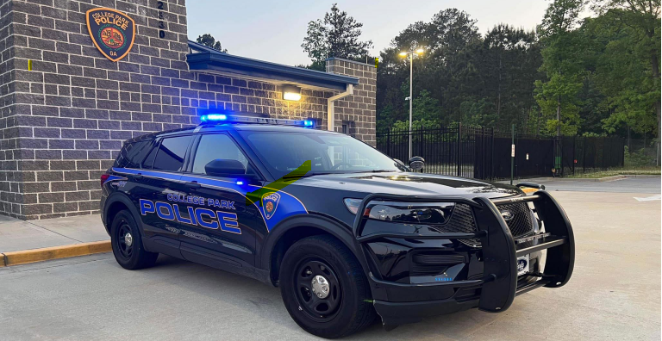

COLLEGE PARK POLICE DEPARTMENT

2023 ANNUAL REPORT
CHIEF CONNIE ROGERS
MISSION AND VISION STATEMENTS

OUR MISSION:

The mission of the City of College Park Police Department is to serve the community utilizing 21st Century Policing practices to promote effective crime reduction, while building public trust, and collaborating with community and business stakeholders. To maintain public trust, it is our responsibility to conduct ourselves with the utmost professionalism, respect, and integrity, while always adhering to the highest ethical standards.

OUR VISION:

The City of College Park Police Department is committed to accomplishing our mission with the use of intelligence-led policing-based approaches in all our policing strategies. Our commitment to exceptional public service will serve as the guiding principle for our relentless crime prevention.

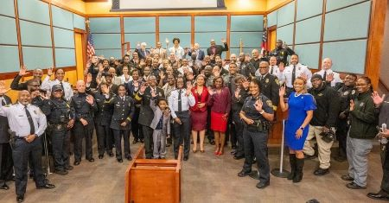

TABLE OF CONTENTS

2. Mission and Vision Statement

4. College Park Municipal Governing Authority

5. Message from the Chief

6. Executive Staff

7. Organizational Chart

8. Agency Goals

10. Crime Statistics

13. Municipal Court

14. Uniform Patrol

16. Investigations

18. Support Services

22. Community Outreach

29. South Metro S.W.A.T

30. College Park Police Department Awards

COLLEGE PARK MAYOR AND CITY COUNCIL

The College Park Police Department salutes our municipal governing authority.

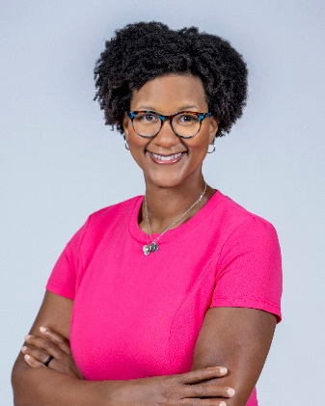
Mayor
The Honorable Bianca Motley Broom

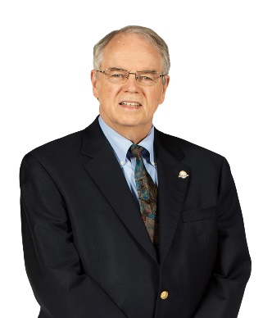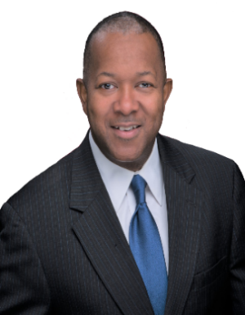
Ward 1 Ward 2
Ambrose Clay Joe Carn

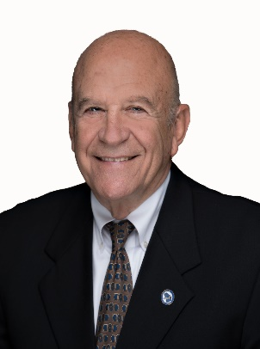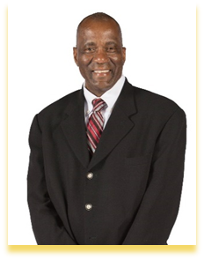
Ward 3 Ward 4
Ken Allen Roderick Gay

MESSAGE FROM THE CHIEF
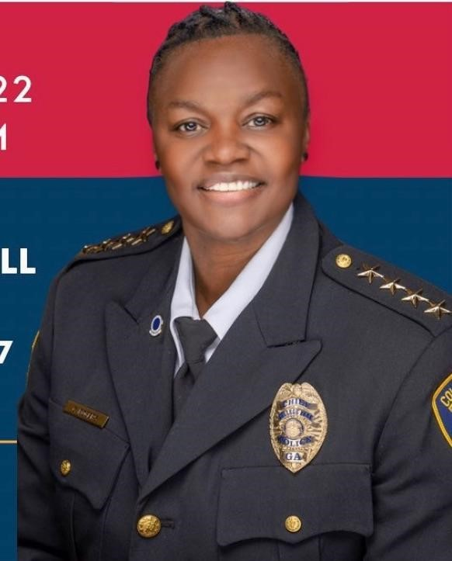
We appreciate you taking the time to review the College Park Police Department's 2023 Annual Report. This report will provide an overview of the accomplishments and obstacles encountered by the College Park Police Department (CPPD). The officers and staff of the College Park Police Department exhibit unwavering dedication and compassion while delivering police services of the utmost professionalism to the residents and visitors of the City of College Park.

The purpose of the CPPD's End of Year Report is to ensure information is communicated to each community member in an open, transparent way while revealing many of the initiatives, awards, and recognition and an understanding of police enforcement activity. We extend a warm invitation to you to visit our department at any time to voice your concerns and become acquainted with your officers.

The past year has presented CPPD and the City of College Park with challenging circumstances. With much anticipation, we anticipate that 2024 will bring the resumption of numerous CPPD programs that have become so popular. The police department cordially invites you to participate in our numerous initiatives as we work together to ensure the safety of the City of College Park. Our community partnerships will be fostered through the return of the Citizen's Police Academy, the implementation of the Neighborhood Watch Program, and the establishment of a real-life crime center equipped with cutting-edge technology.

I want the citizens of College Park to know that I am incredibly thankful for the opportunity to serve as your Chief of Police. I thank the Mayor, City Council, City Manager, and staff for supporting CPPD, our mission, and our people. I want to acknowledge our staff and volunteers for their diligent efforts and selfless dedication in ensuring the safety of our streets and communities daily. We wish each of you a safe and healthy 2024.
Sincerely,
Connie Rogers
Chief of Police

EXECUTIVE LEADERSHIP

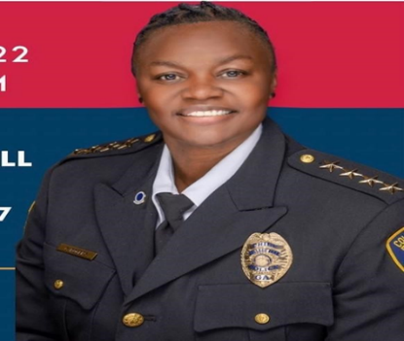
Chief of Police
Connie Rogers

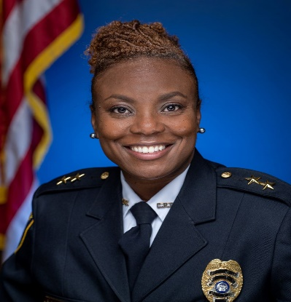
Deputy Chief
Sharis McCrary

Major Marcus Dennard Major Onika Manning
Support Services Commander Operations Commander
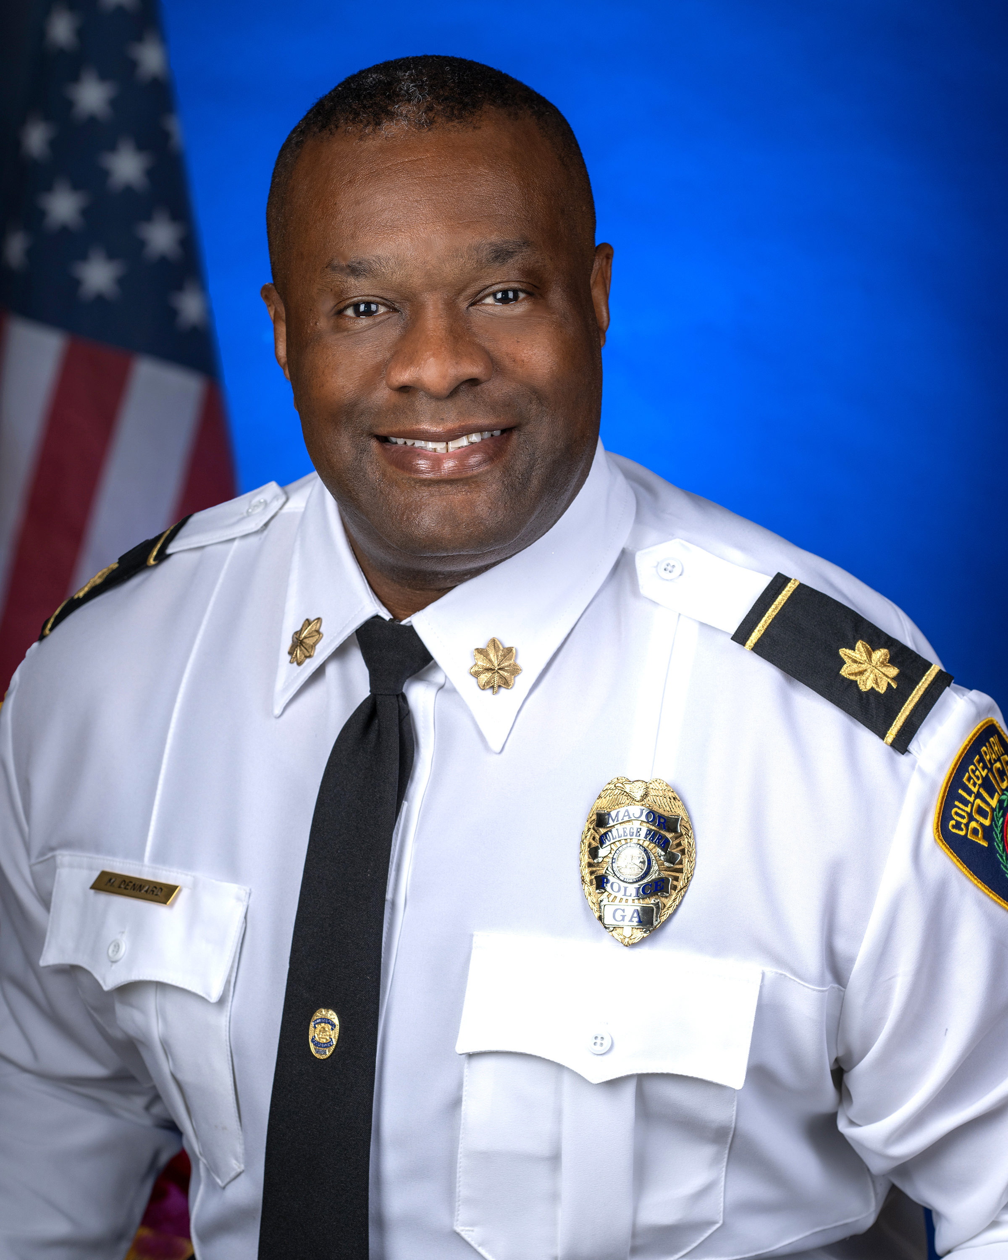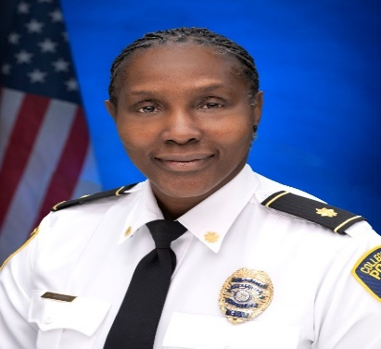

ORGANIZATIONAL CHART

Connie Rogers
Chief of Police

Jewel Dunlap
Executive Assistant

Onika Manning Sharis McCrary Marcus Dennard
Major Deputy Chief Major
Operations Support Services
Municipal Court
Judge & Admin Assist
Uniform Patrol Court Clerks
Four (4) Shifts E911
Communications Supervisor Dispatchers
Validation Clerk Part-Time Dispatchers
Patrol Lieutenants
Four (4) Shifts
OPS CID

Patrol Sergeants
Four (4) Shifts Lieutenant Training & Accreditation CID Lieutenant
Sergeant Background and Recruitment CID Sergeant
Patrol Officers Fleet Management Detectives
Four (4) Shifts
Support Services Crime Scene
Traffic Unit Sergeant Property
&
Officer Evidence

Crime Suppression Unit Records Clerks Admin Coordinator
Officer

Building Maintenance/Custodian
Community Oriented Policing (COPS)

Jail Operations
Four (4) Shifts

AGENCY GOALS

Field Operations Division:

- Continue the use of Body Cameras by all police officers. This will assist with officer accountability in reviewing calls for service. The pending implementation of Axon Fleet 3 in-car video system will significantly increase the effectiveness of this practice.

- Continue efforts to integrate the use of new Taser 7. This equipment can aid police officers when encountering combative persons where force may be necessary.

- Continue to track open record requests related to police activities and meet state mandated requirements.

- Encourage participation in career advancement and leadership training for management and supervisory staff; FBI Leeda, FBI Academy, and Guadian Leadership.

- All sworn personnel attend Crisis Intervention Training.

- Increase staffing by 20% to include both sworn and civilian staff.

Criminal Investigations Division:

- Utilize the Intelligence Led Policing Model to share information internally and externally outside the department to assist in investigating incidents.

- Increase the clearance rate of Part 1 crimes by 5%.

Corrections:

- Decrease booking time for all inmates processed into the facility. Establish and maintain 100% accountable of all inmate property. Maintain the 90-day standard for disposal of unclaimed property.

AGENCY GOALS (continued)

E-911:

- Ensure all new and current 911 personnel attend relevant training to maintain and increase their skill set and knowledge.

- Track call taking and response times for quality control and improvement.

Municipal Court:

- Achieve and maintain 100% accuracy with court and citation entries and customer service interaction.

- Achieve and maintain 100% accountability of all monies received, ensuring accurate balancing with receipts.

- Hire the necessary court personnel to bring staffing levels up.

CRIME STATISTICS

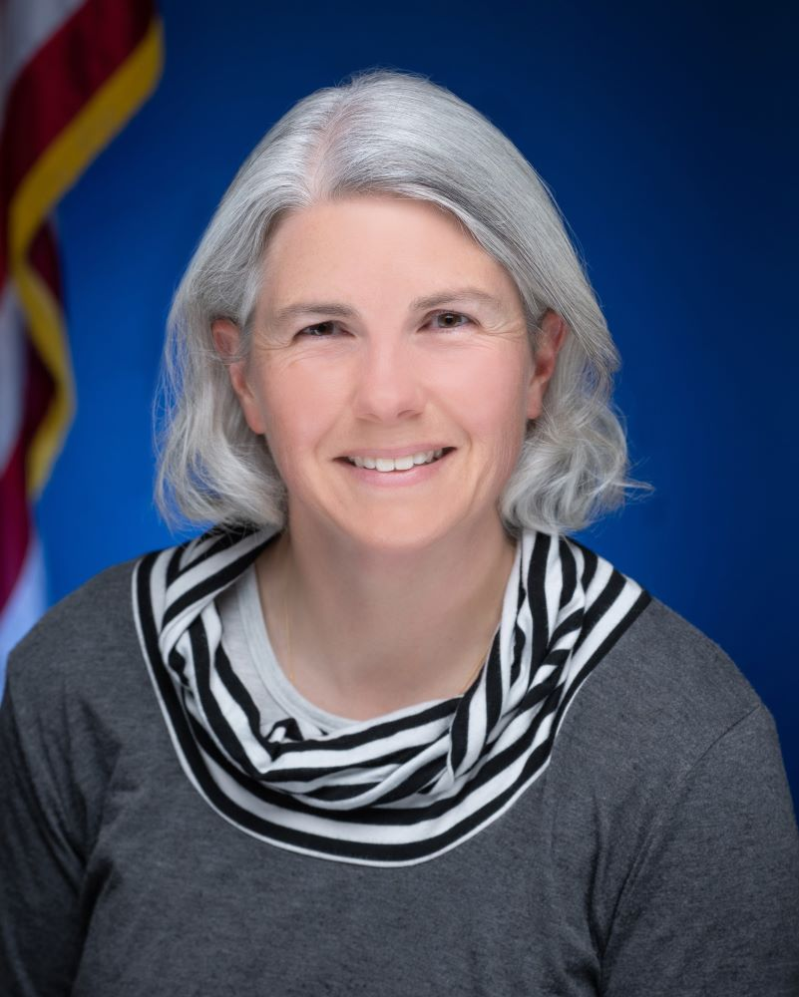
Dawn Chappell -Crime and Intelligence Analyst

Dawn has been with the Police Department for just over 30 years. Dawn began her career with the city as a part-time employee, doing odd jobs throughout the city while in college. She then came to work full-time for the Police Department as a dispatcher in September 1993. After a few years in dispatch, she was transferred to CID as the receptionist. While in CID, she discovered that she enjoyed researching information for cases and following trends and patterns. Dawn was allowed to explore cases and send out information on crime trends as they were identified and instantly saw where this was beneficial to CID and the entire uniform division. Dawn has been the crime analyst for the department for over 15 years and has assisted many other departments with training their crime analysts.

2023 National Incident-Based Reporting System (NIBRS) Data for College Park Police Department

To gain a measurement of crime trends, College Park Police Department participates in the Federal Bureau of Investigation's Uniform Crime Reporting (UCR) Program. As part of a national transition required by the FBI in 2019, CPPD converted to the National Incident-Based Reporting System (NIBRS). NIBRS uses incident-based reporting to identify all elements within an incident, whereas SRS records only a synopsis of the event. This new detail includes information on the type and frequency of offenses, arrest data, and relationships between involved parties. The NIBRS method of reporting is intended to provide a more comprehensive representation of crime trends and patterns by requiring local, state, and federal departments to report crimes in a more robust and uniform manner.

National Incident -Based Reporting System (NIBRS) Type A offenses, the following categories were pulled for 2023 to closely represent “Crimes Against Persons”: Murder, Rape, Robbery, and Aggravated Assaults and “Crimes Against Property”: Burglary, Larceny, and Motor Vehicle Thefts.

CRIMES AGAINST PERSONS CRIMES AGAINST PROPERTY
MURDER BURGLARY
13 105

RAPE AGGRAVATED ASSAULT
9 133

MOTOR VEHICLE THEFTS ROBBERY
215 42
LARCENY
800
CALLS FOR SERVICE

Calls for service consist of any call to which the College Park Police Department responds regardless of whether a report is generated. Calls for service can result in many types of reports, including accident or incident reports. Calls may also be officer-initiated in response to a citizen "flag-down" or proactive patrols initiated by officers to deter and prevent crime. 2023 witnessed a 9.5% increase in Calls for service as compared to 2022.

76724 86786

2022 CALLS FOR SERVICE 2023 CALLS FOR SERVICE

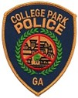

OFFICER ACTIVITY

Officer Activity is represented by a number of incident reports, citations, and warnings written, as well as field interviews completed, arrests made, and accidents investigated. In 2023 we witnessed a 13.4% increase in Total Arrests as compared to 2022.

1826
1573

2022 ARRESTS 2023 ARRESTS

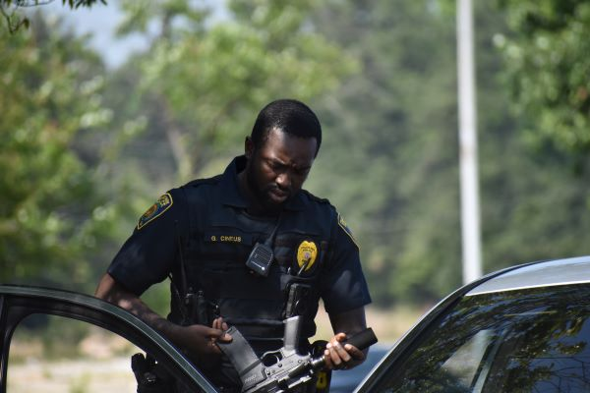

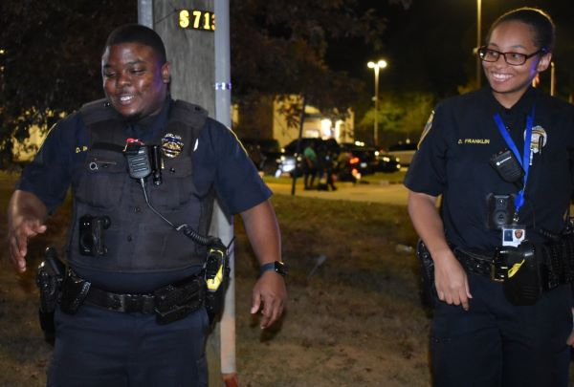

MUNICIPAL COURT

The Municipal Court of College Park is a municipal court (a court of law with jurisdiction limited to a city or other municipality. It typically addresses "violations of city ordinances and may also have jurisdiction over minor criminal cases) that tries ordinance violations, issues criminal warrants, conducts preliminary hearings, and hears misdemeanor cases on traffic and other minor criminal crimes.

Fees Collected

Calendar Year 2022 Calendar Year 2023

$467,562.37 $902,911.60

UNIFORM PATROL
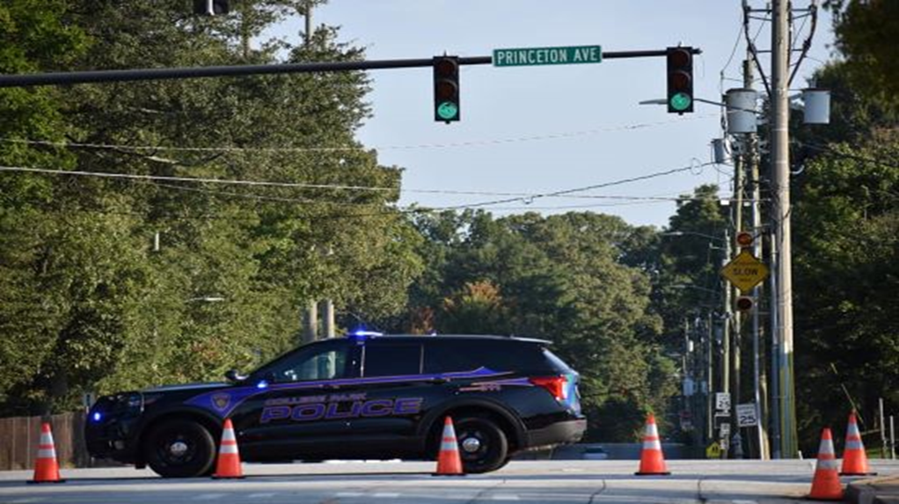

The Uniform Patrol Division is the largest and most visible division within the department. This division is broken down into four separate shifts and each shift is supervised by a Lieutenant and two Sergeants. The division commander holds the rank of Major.

College Park officers are deployed daily and nightly across the city to protect College Park's residents, businesses, and visitors. Patrol officers serve as the initial responders to the department's requests for service, and they are required to possess the capability to manage a wide range of complex, diverse circumstances. College Park officers must address all requests for assistance and compose related reports. Furthermore, College Park officers carry out a range of additional tasks in addition to these obligations. The other duties consist of neighborhood patrols, proactive and intensive patrols in high-crime areas, enforcement of traffic laws, conducting accident investigations, directing traffic, field interviews, preliminary criminal investigations, providing support to crime victims, searching for missing individuals of all ages, gathering information from residents regarding neighborhood concerns, and, when required, apprehending criminals.

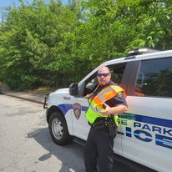

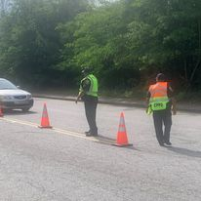

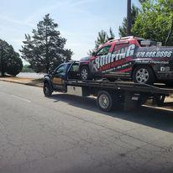

Officers participating in a road safety check, identifying safety concerns and risks on local roads. This process helps reduce the number of accidents on the road and serves as a starting point for road improvements that can improve the flow of traffic and increase public safety.

INVESTIGATIONS
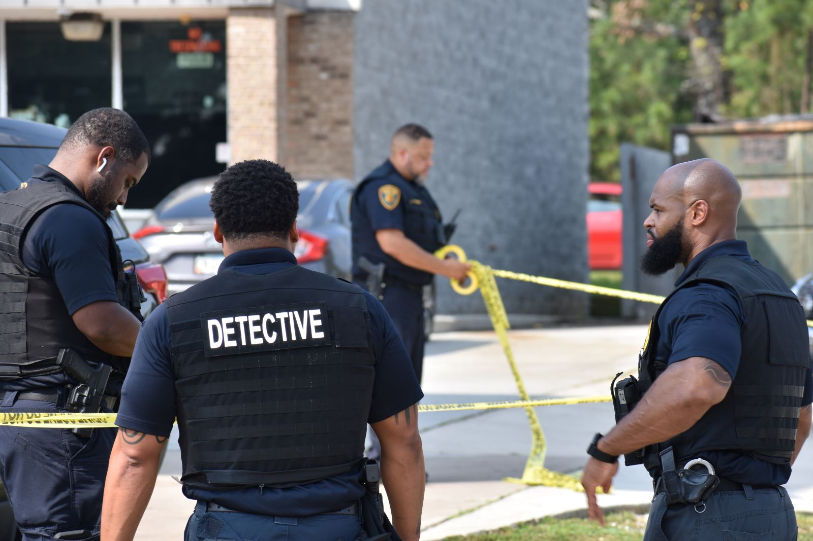
The Criminal Investigations Division (CID) is responsible for determining follow-up investigative needs for all criminal incidents, and those cases needing special attention or long-term investigation.

The CID supervisory team reviews incident reports daily and applies a formal case screening process to all crimes to ensure that investigative resources are assigned to those cases which can most benefit from the expenditure of additional investigative effort. Screening is based on research and experiences within the agency and case solvability factors.

The Criminal Investigations Division (CID) is under the command of a Major and is supervised by a Lieutenant and a Sergeant who are responsible for assigning cases and overseeing daily operations. The division consists of six detectives who handle all criminal investigations. CID also has one crime scene investigator.

Cases Assigned Arrests Search Warrants

1567
2

60

GODBY RD/WEST FAYETTEVILLE RD -MURDER SOLVED

On August 24, 2023, Detectives responded to Godby Road and the West Fayetteville Road intersection in reference to a person shot. The victim was shot multiple times while seating in his vehicle at the traffic light. Detectives conducted a canvas of the area and reviewed video footage attempting to identify potential leads. Upon locating a witness and reviewing the convenience store video footage detectives were able to get a tag number belonging to the suspect vehicle. Within hours of the initial call, the suspect and his vehicle were tracked to a home located in McDonough, Georgia, where with the assistance of Henry County Police Department, 20-year-old Victor Isom, was arrested.

College Park Police Chief Connie Rogers expressed her satisfaction with the quick capture of this violent offender, stating that the victim and the community can now feel safer. She commended the diligent work of the detectives and community partners who collaborated to resolve the case swiftly.

SUPPORT SERVICES

The mission of the Support Services Division is to facilitate the operational support
of the police department, foster the effective and efficient delivery of police services, and ensure that quality training and standards are maintained within the College Park Police Department.

The Support Services Division is comprised of several different functional areas including E-911, Records Management, Terminal Agency Coordinator, Training, Fleet Management, Court Security, Property and Evidence, and Background and Recruitment. The Support Services Division is under the command of a Major. Support Services is managed by an E-911 Supervisor and two (2) Sergeants, who.
oversees the day-to-operations.

Civilian Support Staff
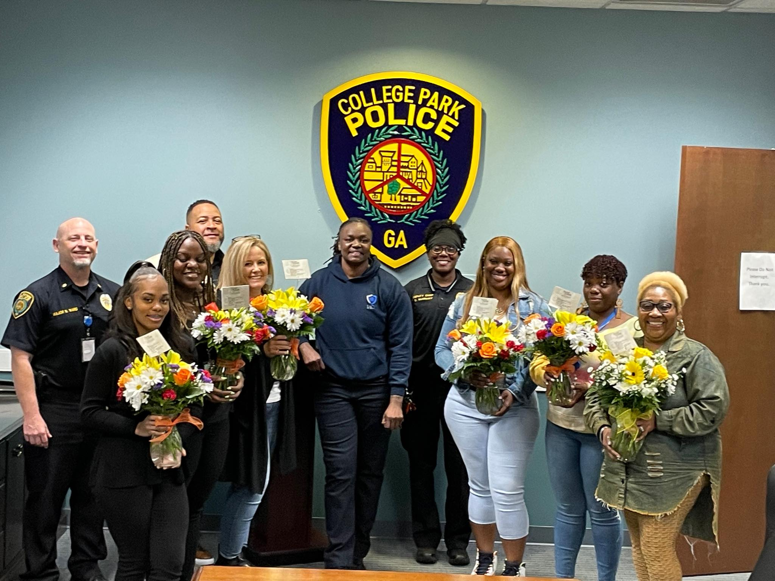
The civilian support staff were presented with flowers on Administrative Professional Day.

E-911
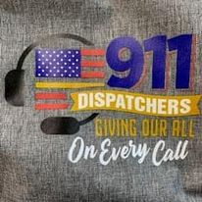
The College Park E-911 Center receives, classifies and prioritizes calls from the public and dispatches the calls that require police response; transfers and/or directs calls that do not require police response to the proper agency/unit; performs stolen checks on items, wanted/missing checks on persons and hit confirmations from entering agencies, and completes GCIC/NCIC forms on missing persons and stolen autos.

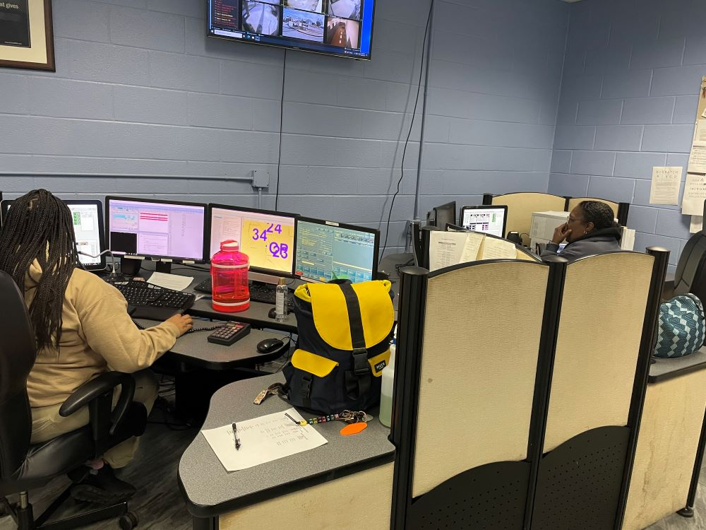
The College Park Police Department E-911 Dispatchers hard at work answering calls.

Background and Recruitment/Training Unit
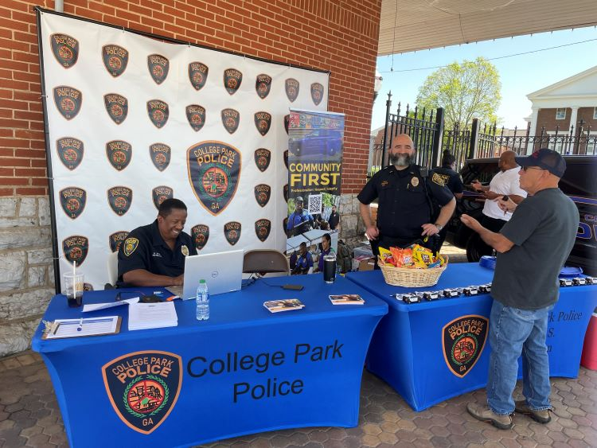
The Background and Recruitment and Community Services at a pop-up job fair on Main Street at the Train Depot.

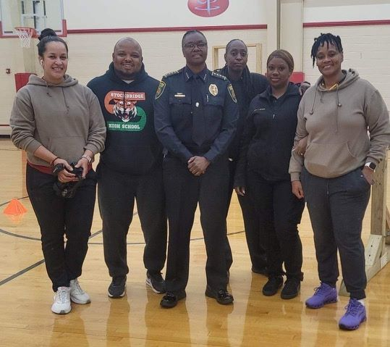
Background and Recruitment and COPS Officers conducting the Georgia State mandated physical agility testing all recruits must pass to complete Basic Law Enforcement Training.

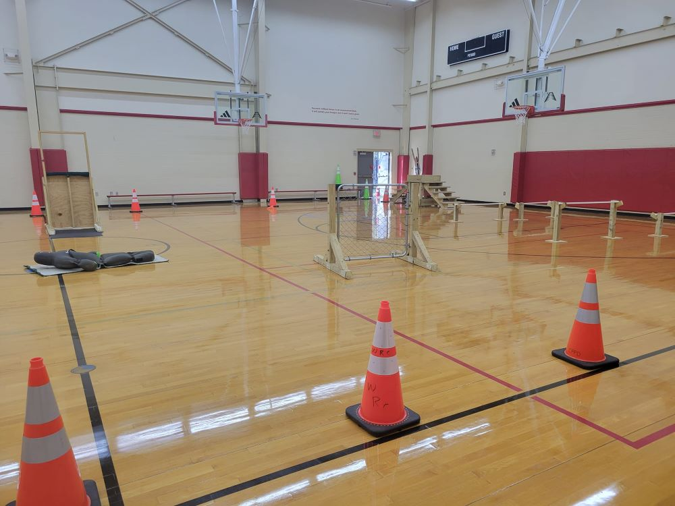
Special thanks to the Department of Parks, Recreation, & Cultural Arts for the use of the Tracey Wyatt Recreation Center to host our physical agility tests.

The College Park Police Department is committed to hiring highly qualified and professional police officers and invests in their continued growth through rigorous training requirements.

Training standards for law enforcement officers and agencies are established by the Georgia Peace Officer Standards and Training Council (POST).

CALENDAR YEAR 2023

Recruitment – New Officers Hired Training
21 10,785 hours

COMMUNITY OUTREACH

During 2023, the Community Oriented Policing (COPS) Unit interacted with thousands of residents, businesses, houses of worship, and those visiting College Park. The College Park Police Department hosted and participated in a variety of events during the year, both small and large. The Police Department’s goal has been to build strong and lasting relationships with those in our community through crime prevention efforts and community events.

Senior Social
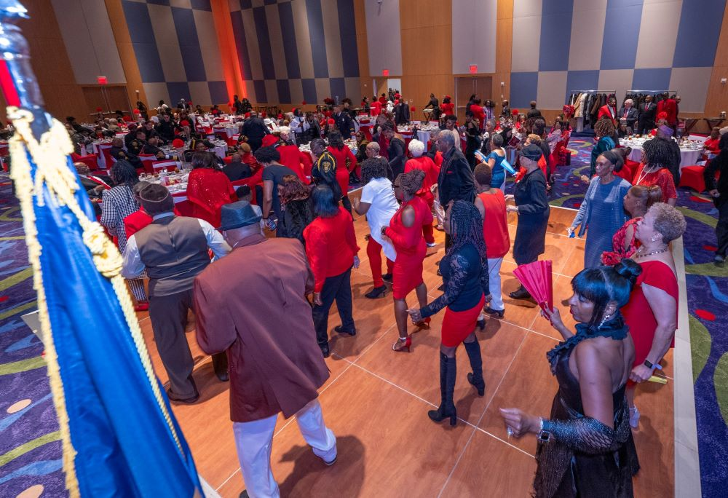The Police Department hosts a Valentine’s Senior Social every year to acknowledge the role and significance of the seniors in our community.

Steering Wheel Lock Giveaway
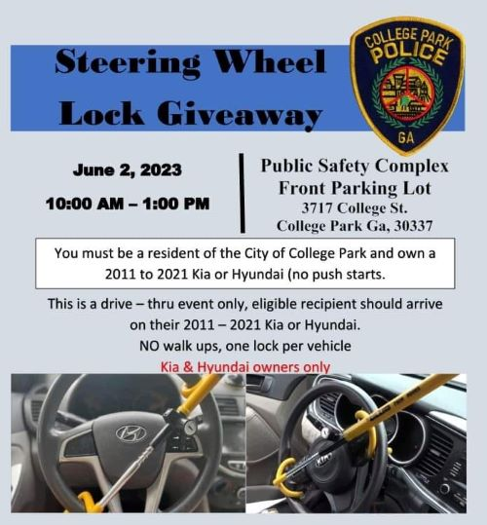

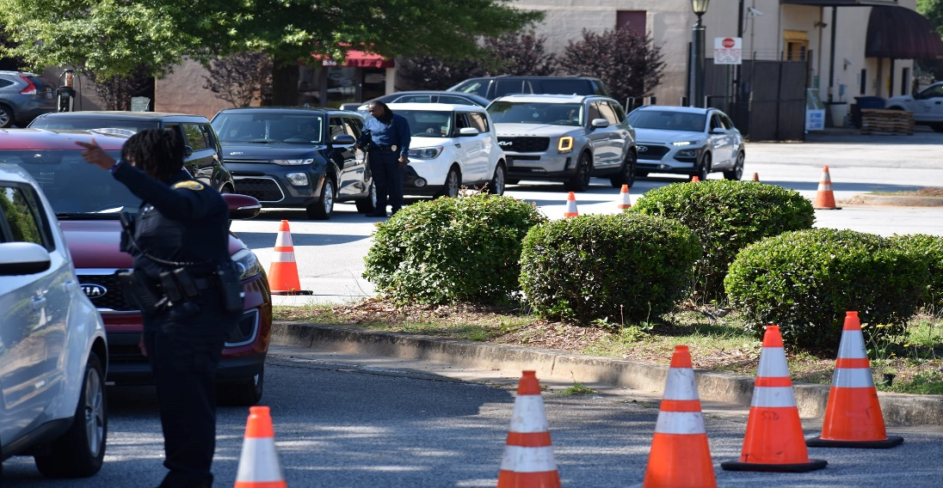

The College Park Police Department teamed up with Kia Corporations to host a free steering wheel lock giveaway on June 2, 2023, to College Park residents to help Kia and Hyundai owners protect their vehicles from being stolen. Those who own a Hyundai model manufactured between 2016 to 2021 or a Kia model manufactured from 2011 to 2021, qualified to receive a free streering wheel lock.

The goal of the event was to help curb car thefts of Kia and Hyundai vehicles, which started to rise after the viral TikTok "Kia challenge." Hyundai and Kia's vehicles have been easily targeted because they use a mechanical key to start rather than a key fob and push-button.

Gun Buy Back Event
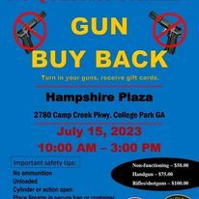
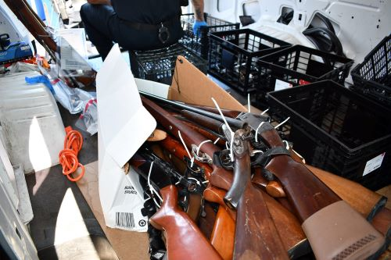

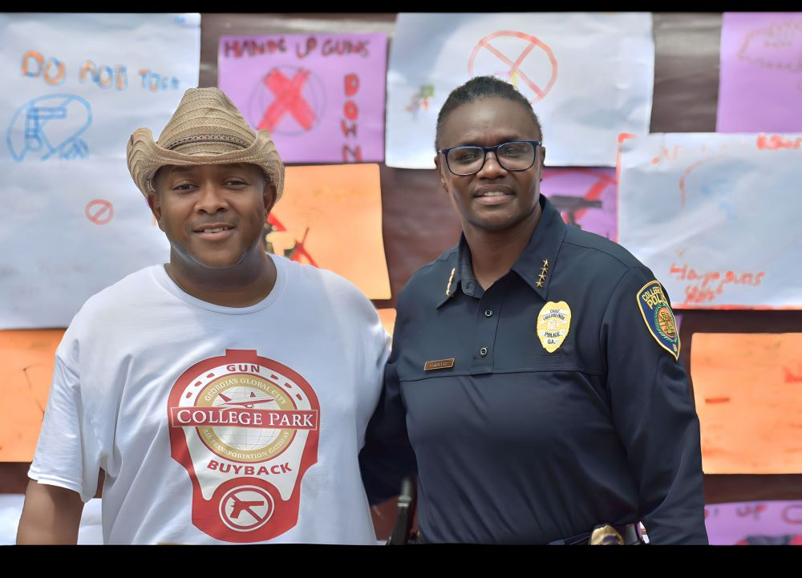

With the support of Councilman Carn and City leadership the Police Department hosted a gun buy back event on July 15, 2023. The goal of the event was to prevent firearm violence by reducing the stock of firearms in a community. Gun buybacks also serve as venues for raising awareness of the risks associated with firearms, educating participants about safer firearm storage, and connecting violence prevention organizations, all of which could potentially lead to reductions in firearm crimes, injuries, or deaths.

The College Park Police Department collected eighty-three (83) weapons on that day that will not be used to commit a crime.

National Night Out

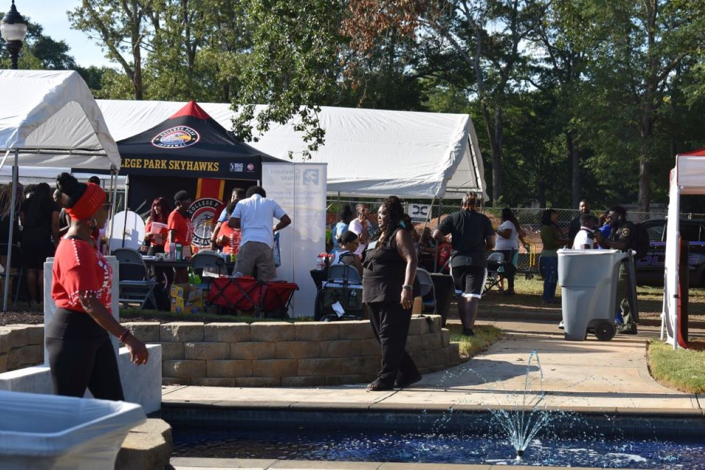

National Night Out is an annual community-building campaign that promotes police-community partnerships and neighborhood camaraderie to make our neighborhoods safer, more caring places to live. National Night Out enhances the relationship between neighbors and law enforcement while bringing back a true sense of community. Furthermore, it provides a great opportunity to bring police and neighbors together under positive circumstances.

This event could not take place without the help of our neighboring law enforcement agencies participation and College Park business stakeholders.
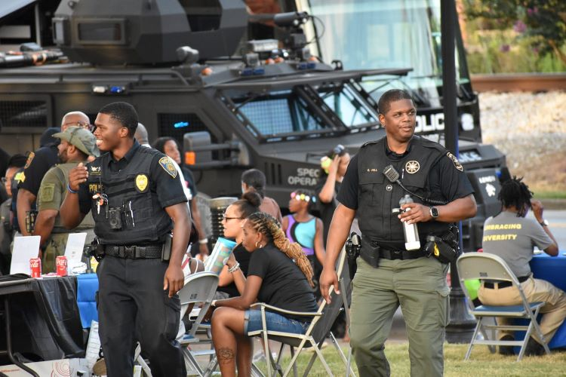

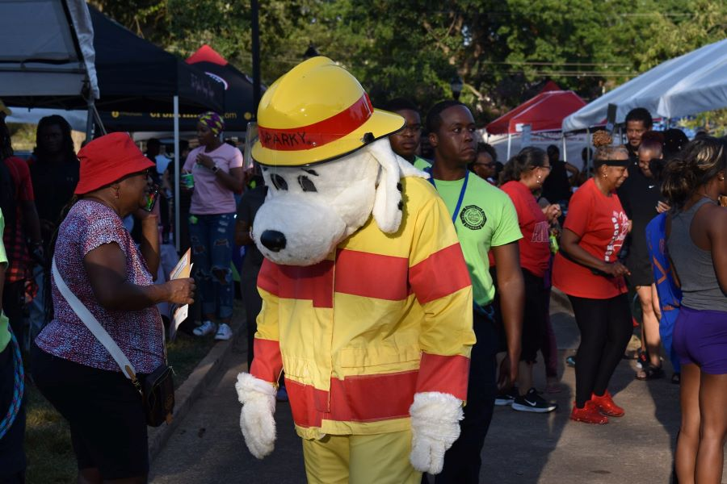

Trunk or Treat

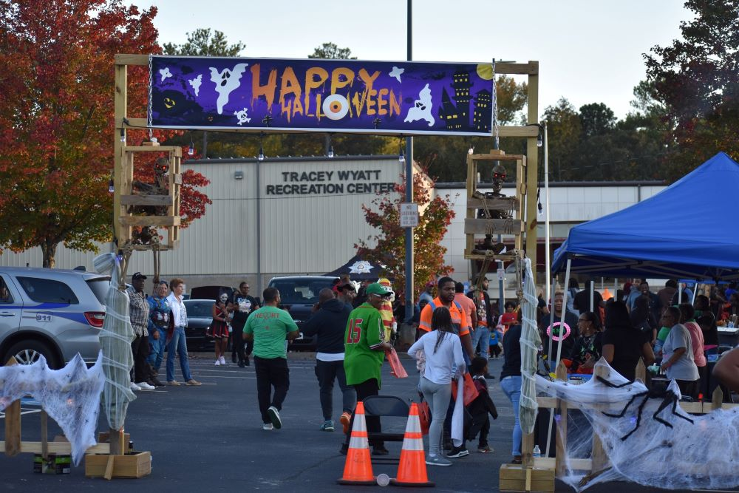
Trunk or Treat has become one of the Police Department's most anticipated events. Using the Tracey Wyatt Recreation Center parking lot, our annual Trunk or Treat allows for a contained area, so children are at less risk of being hit by a vehicle on a dark road. Trunk-or-Treat also allows for another opportunity for the Police Department to get to know the families in our community.

Town Hall Meetings

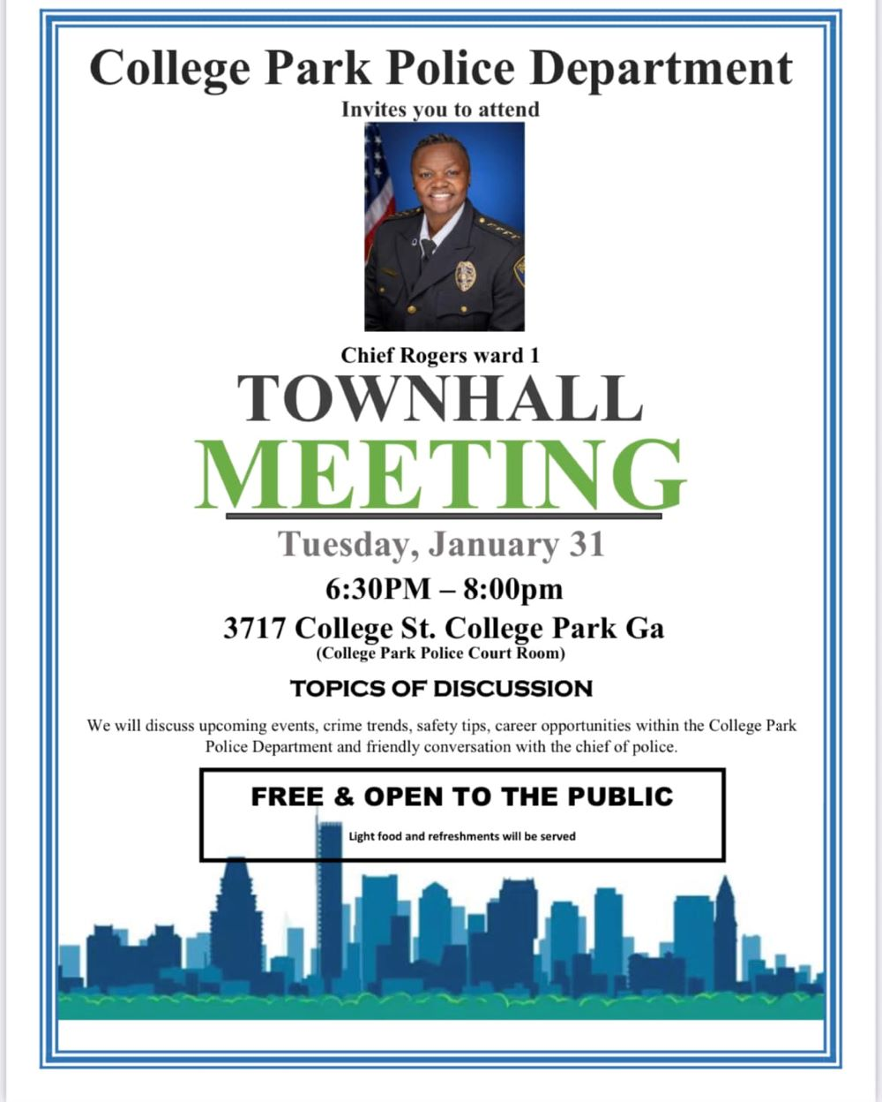
Chief Rogers hosted Town Hall meetings throughout the year in each Ward to discuss police events, crime trends, safety tips, quality -of-life- issues and to have productive dialogue with residents about topics that are important to them.

Shop With a Cop
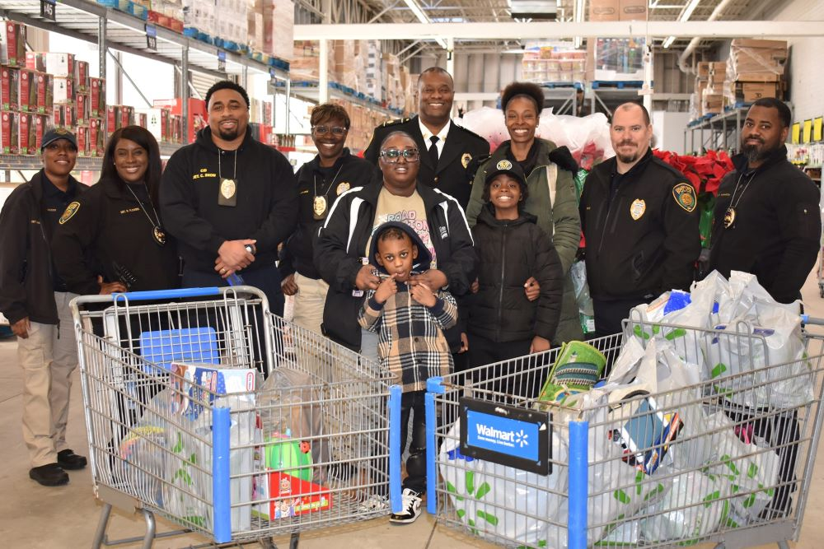
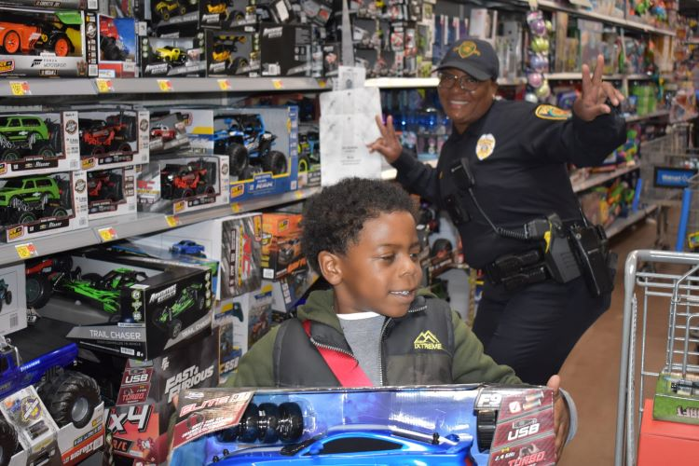
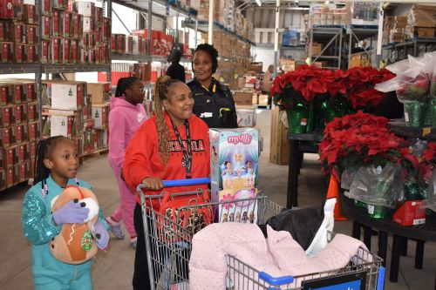
The Shop with a Cop program provides students whose families are having financial issues during the holidays with a great shopping experience. Families must reside inside the city limits of College Park, children must be between the ages of 3 and 13 to participate, families cannot have participated in the program in the last 3 years, and the children must be enrolled in school.

The Police Department assisted ten (10) families during the holiday season.

SOUTH METRO SWAT (SPECIAL WEAPONS and TACTICS)

The College Park Police Department has five (5) active members on the South Metro SWAT Team. The South Metro Swat Team is an elite team of officers from local metro police agencies that are specially trained to handle threatening situations that fall outside the capabilities of patrol officers. The SWAT Team is primarily used to serve high-risk search and arrest warrants across various divisions.

SWAT is also used for other unusual occurrences, including barricaded subjects, sniper situations, dignitary protection and other special assignments. Each SWAT team member is fully equipped and able to respond directly to the scene of an incident for immediate deployment. SWAT also works closely with the Department’s Crisis Negotiator to assist the Incident Commander in a particular situation in working toward a successful negotiated resolution.

SWAT Team members train several times a month to include firearm proficiency, building entry and clearing skills, hostage rescue, less lethal force options and terrorist incident resolution.

South Metro SWAT is comprised of College Park Police Department, South Fulton Police Department, Fulton County Schools, Fairburn Police Department, and East Point Police Department.

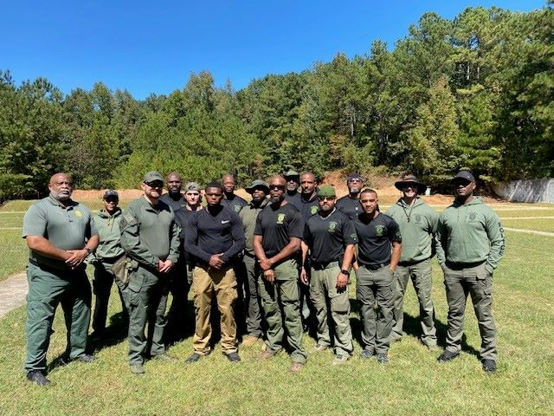

77
CALL OUTS

COLLEGE PARK POLICE DEPARTMENT AWARDS

Sergeant Nico Goss
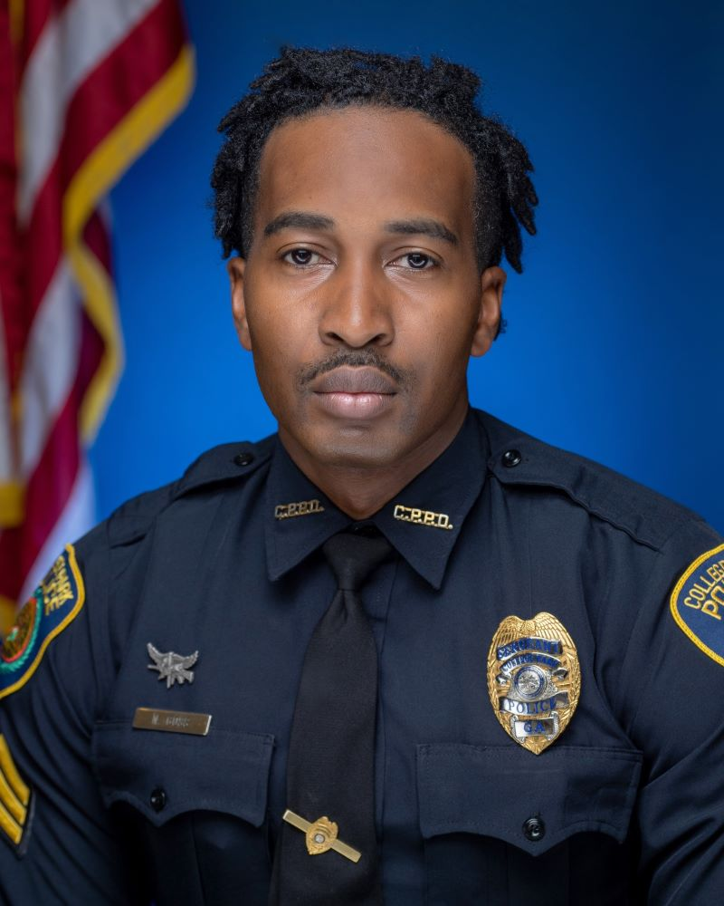
This is awarded to the supervisor who has distinguished themselves above all other supervisors during the year.

Officer of the Year
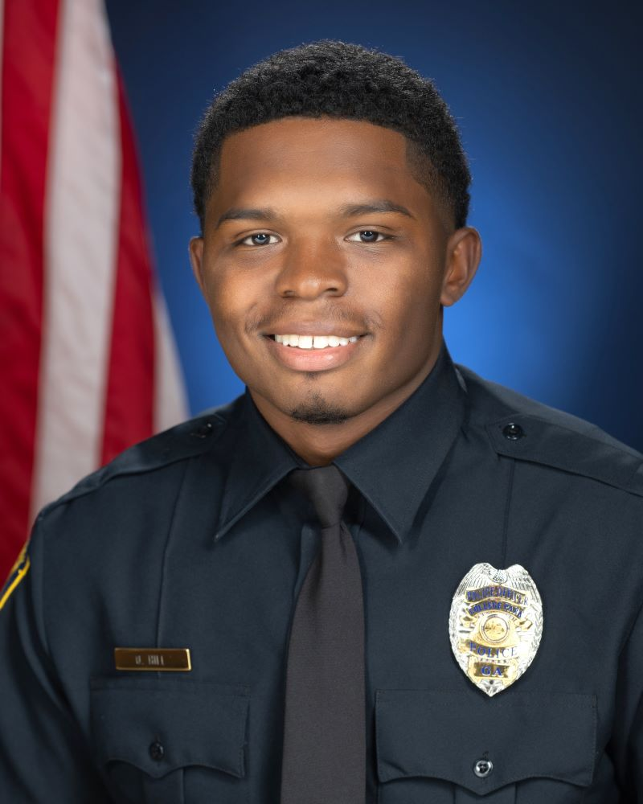
This is awarded to the officer whose work performance and actions are clearly above the call of ordinary duty.

